**LAPORAN**

**Tugas 4**

**Oleh :**

**Irpan Ginanjar (1127050077)**

**Suhendar (1127050153)**

**Sequence Diagram “Kelola No. Meja Restauran Pizza”**

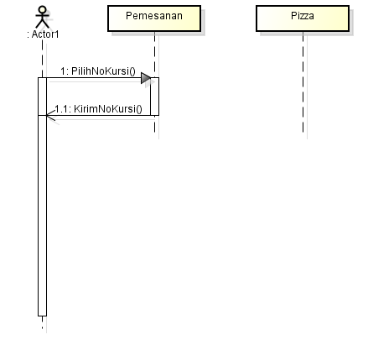

**Sequence Diagram “Kelola Pemesanan”  
